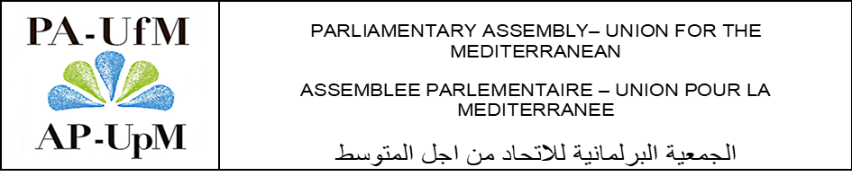

DRAFT RECOMMENDATIONS

Committee for the Promotion of the Quality of Life,
Exchanges between Civil Societies and Culture

Considering the importance of the role of culture in achieving the Sustainable Development Goals (SDGs), as a true pillar of development for building a green future, and taking into account the fact that culture is a medium for spreading and sharing knowledge, mainly through raising awareness of the current changes and challenges that our world is facing. We hereby declare the following:
- To ensure that the cultural sector becomes eco-friendly in the countries of the Mediterranean region, by increasing knowledge, enhancing skills and promoting good practices;
- To coordinate actions among Mediterranean countries aimed at preserving the environment;
- To involve authorities, local actors, professionals and experts, and civil society in this process that aims at putting the cultural dimension at the core of the sustainable development in the Mediterranean region;
- To support the collective efforts and joint action of the countries in the Mediterranean region, in developing and implementing appropriate Conventions and efficient sectoral policies that could provide an added value to the international efforts;
- To exchange experiences and expertise among the countries of the Mediterranean region with the aim of creating a "greener" future for the region;
- To integrate local cultural policies, green cities and sustainable cultural industries in the achievement and purpose of any cultural project;
- To take advantage of all potential means and opportunities available in the Mediterranean region in terms of harnessing the impact of culture in raising awareness of the challenges related to climate change;
- To think on common projects that would contribute to a greater cultural integration among the Mediterranean countries;
- To strengthen the participation of the Mediterranean countries in the work of Organisations and in regional and international Forums;
- To promote a creative and sustainable cultural industry (reducing the carbon footprint of productions, decreasing wastes and energy costs of filmmaking...), to invest in infrastructures (renovation of cinemas, film studios and museums, as well as creating eco-schools, thermal renovation of buildings...) and to support the ecological transition in the different cultural fields (eco-responsible festivals and concerts, using recycled and recyclable materials, utilizing LED lighting...);
- To include the concept of environmental protection in schools and university systems, and to involve young people and children of the Mediterranean region in this process of energy transition, through cultural exchange programmes, after school activities and summer camps aimed at raising awareness of climate requirements and the need to work jointly for the preservation of the environmental heritage through culture, in order to achieve a greener world;
- To create a working group on culture and sustainable development, made up of the relevant experts from the member countries of the Parliamentary Assembly-Union for the Mediterranean. The working group will be in charge of exploring and discussing projects and initiatives linking culture and the environment, exchanging best practices, and unifying objectives and instruments for implementing public policies in the different countries of the region.

